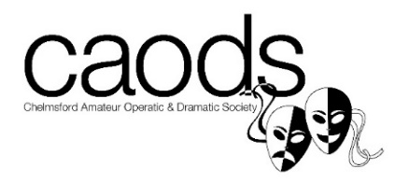

DIRTY ROTTEN SCOUNDRELS 2018
AUDITION FORM
Name:
Address:
Postcode:
Home Number:
Mobile Number:
Email Address:

AUDITIONING FOR:
CONSIDER FOR UNDERSTUDY: YES / NO (please circle)

I WOULD LIKE TO BE CONSIDERED FOR:

I AM AUDITIONING FOR A DANCER*: YES/NO (please circle)
I AM AUDITIONING FOR ENSEMBLE: YES/NO (please circle)
* (Anyone auditioning for a dancer and has not auditioned for a principal singing role will also need to audition for the Ensemble vocal).

Please list any holiday dates or rehearsals that you are unable to attend:

I can attend the Publicity Day in Chelmsford City Centre on Sat 3 February 2018 YES/NO

Please submit this form no later than Wednesday 18 October 2017 to Chairman of the Audition Panel, Christine Yorke-Edwards, by HAND or EMAIL c.yorke-edwards@blueyonder.co.uk. Thank you!

PLEASE NOTE: re SOCIAL MEDIA TAGGING: We assume you hereby give your consent to be tagged in any Social Media Publicity Campaigns for DIRTY ROTTEN SCOUNDRELS, unless you inform the Executive Committee otherwise. Please contact Cassie Estall cassie.estall@gmail.com with any queries.

